1. Engage with me! Tabling 10/29, 10/31

What is VASAM? Asian American Studies vs. Asian Studies? What do we want? Why Asian in America?

Vassar Asian American Studies Working Group (VASAM) is tabling from 12-3pm on Monday (10/29) and Wednesday (10/31) in the College Center. We are going to be answering any questions you have about VASAM and Asian American Studies.

I was thinking of a poster with the words “Engage With Me” in the middle and some questions floating around and a little blurb on the bottom. It should look clean but eye catching. I need to put them up Sunday night and I’ll print them w. My vcash. Could I have a regular letter sized version of this poster and a 4 to a page size of this poster.

1. Vassar Needs a Better Asian American Studies Program.

Could you make the poster I have below, but change the words to “Vassar Needs a Better Asian American Studies Program.”

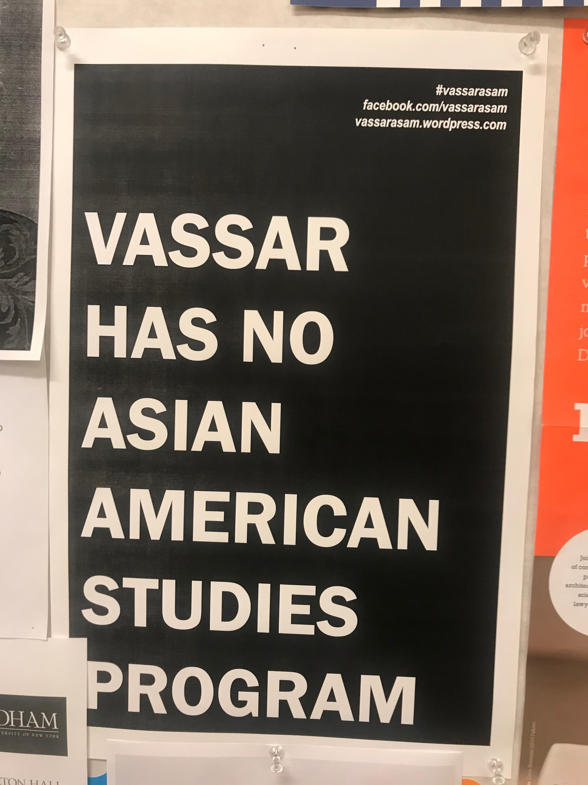

1. Hua Hsu Workshop: Nov. 12, 500-600pm in Rocky 310
   * how about this - I'll talk for 10-15 minutes about my own trajectory, and then I'll talk about 2-3 turning points of asian american representation (in literature, film, and music)? it'll be pretty free flowing. I don't really have a title...maybe just "the evolving politics of asian american representation?"
2. Okihiro:
   1. Nov. 30, 4-5:30pm lecture (Rocky 200)
      1. “Third World Studies and World History: A Conversation”
   2. Q/A, workshop 130-230pm (Faculty Commons/Parlor)
      1. “Asian American Studies: How It Changes Our Views of U.S. History and Society”